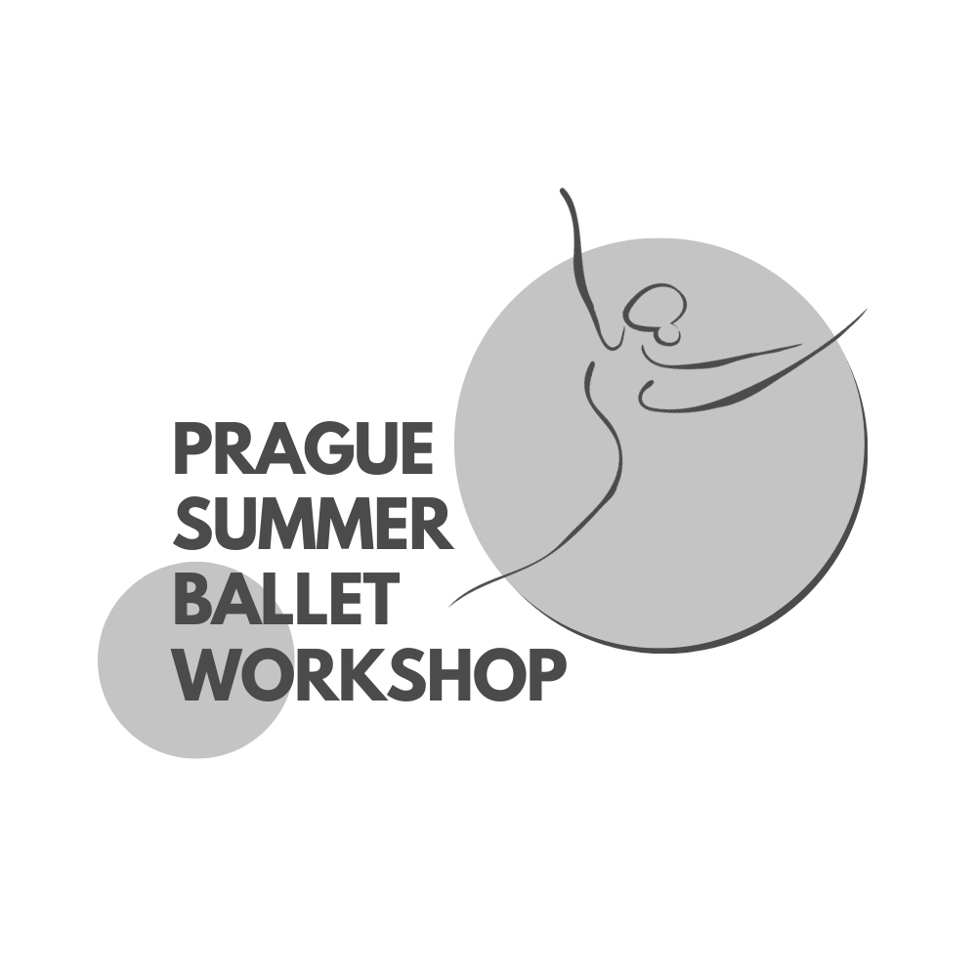
Prague Summer Ballet Workshop 2024
Application Form

Participant Information:

First Name:

Last Name (Family Name):

E-mail Address:

Phone Number with International Dialing Code (+000 123 456 789):

Country/State/City:

Age (Years):

Gender (Female/Male):

Ballet Experience or Information About Your Dance School:

Any Health Restrictions or Conditions Instructors Should Be Aware Of:

Brief CV/Information About Yourself:

Workshop Details:

Desired Workshop Duration (Select One):
Leave the checkmark (✓) next to your chosen option and delete the checkmarks ( ) from the other options.

(✓) 1-week workshop
(✓) 2-week workshop

Parent/Guardian Information:

First Name:

Last Name (Family Name):

E-mail Address:

Phone Number with International Dialing Code (+000 123 456 789):

Will the Parent(s) Accompany the Participant to Prague?
Leave the checkmark (✓) next to your chosen option and delete the checkmarks ( ) from the other options.
(✓) Yes, accompanying for the entire duration (1 or 2 weeks) WITH participating in the parent's workshop program.
(✓) Yes, accompanying for the entire duration (1 or 2 weeks) BUT WITHOUT participating in the workshop program.
(✓) No, the participant will attend independently.
(✓) Other (please specify):

After completing this document, please save it and submit it via the application form on our website.
Thank you!

